CASE REPORT
Closure of oro-antral fistula with pedicled buccal fat pad. A case report and review of literature

W. L. Adeyemo, M.O. Ogunlewe, A.L. Ladeinde, O. James
Department of Oral and Maxillofacial Surgery, Lagos University Teaching Hospital, Lagos, Nigeria.

Summary
Objectives: Chronic oro-antral fistula following dental extraction is not uncommon. Application of pedicled buccal fat pad (BFP) in the repair of the fistula is rather uncommon in our environment. This article demonstrates the use of BFP in the repair of chronic oro-antral fistula. Methods: A case of a chronic oro-antral fistula of 5- year duration in a 56- year old man successfully repaired with pedicled buccal fat pad after unsuccessful several attempts with other local flaps is presented. A review of relevant literature using MEDLINE is also presented. Results: Complete epithelization of the pedicled BFP was observed after 4 weeks with no postoperative complication. Conclusion: Pedicled buccal fat pad is a reliable flap for the repair of oro-antral fistula. The easy mobilization of the BFP and its excellent blood supply and minimal donor site morbidity makes it an ideal flap. It should also be considered as a reliable back-up procedure in the event of failure of other techniques.

Key words: Closure; oro-antral fistula; buccal fat pad.

INTRODUCTION
Oro-antral communications may develop as a complication of dental extractions, but may also result from accidental or iatrogenic trauma, neoplasm or infection^{1,2}. Some of the traditional methods that are being employed in the repair of oro-antral communications include buccal advancement flaps, palatal rotation and palatal transposition flaps, tongue flaps, nasolabial flaps^{1,3}. Buccal fat pad (BFP) is increasingly being employed in the repair of oro-antral fistula (OAF) and other oral defects worldwide⁴⁻⁹.

Correspondence: Dr. Wasiu Lanre ADEYEMO Department of Oral and Maxillofacial Surgery, Lagos University Teaching Hospital, P.M.B 12003, Lagos, Nigeria. E-mail: lanreadeyemo@yahoo.com
The application of buccal fat pad in the closure of oral defects is either not a common practice or under-reported in Africa. A computerized literature search using MEDLINE for articles published from 1977-2004, revealed only one report of its use from Africa¹⁰.

This article reports a case of a chronic oro-antral fistula successfully treated with the use of a pedicled buccal fat pad after several unsuccessful attempts with other local flaps. A brief literature review is presented; the advantages and possible complications of pedicled BFP are also highlighted.

CASE REPORT
A 56-year old man was referred to the outpatient clinic of the Department of Oral and Maxillofacial Surgery of the Lagos University Teaching Hospital from a General Hospital for the management of a chronic oro-antral fistula in May 2003. The patient was reported to have had an extraction of an upper right first molar about 5 years previously and subsequently developed an oro-antral fistula (OAF). It was also reported that an attempt made to repair the fistula few months after with a local flap failed.

Examination revealed a healthy looking man with no obvious facial asymmetry. Intra-orally, oral hygiene was fair and all teeth were present except the maxillary right first molar. There was a fistula (1.8cm x 1.3 cm) at the depth of buccal sulcus in relation to the edentulous space of the missing tooth with air-bubble around the orifice. There was no discharge from the fistula or any sign of acute infection. Patient’s medical history was not significant. A clinical diagnosis of chronic oro-antral fistula was made. Periapical and occipitomental x-ray views of the sinus were taken to exclude any other antral pathologies.

The radiographs revealed a generalized thickening of right antral mucosa and a defect in the bony floor. An attempt was made to repair the fistula in our clinic under local anaesthesia with the use of buccal advancement flap after placing the patient on Amoxicillin (500mg 8hrly) and Metronidazole (200mg 8hrly) capsules for 7 days. Dehiscence of the wound was noticed 3 days after surgery and by the 7th day, complete wound break down was noticed. Three months after, another attempt with a buccal advancement flap also failed. A decision was then made to employ the use of pedicled buccal fat pad for the repair under local anaesthesia. On the 18th of May, 2004 a right pedicled buccal fat pad was used to repair the fistula.

Procedure: The patient was placed on Amoxicillin capsules (500mg 8hrly) three days before the surgery. Excision of the fistulous tract from the sinus to the oral cavity and freshening of the wound edges done after local anaesthesia with 2% lignocaine with adrenaline 1: 80,000 was achieved (Figure 1).

Figure 1. Oro-antral defect (upper right posterior) after the excision of the fistulous tract.

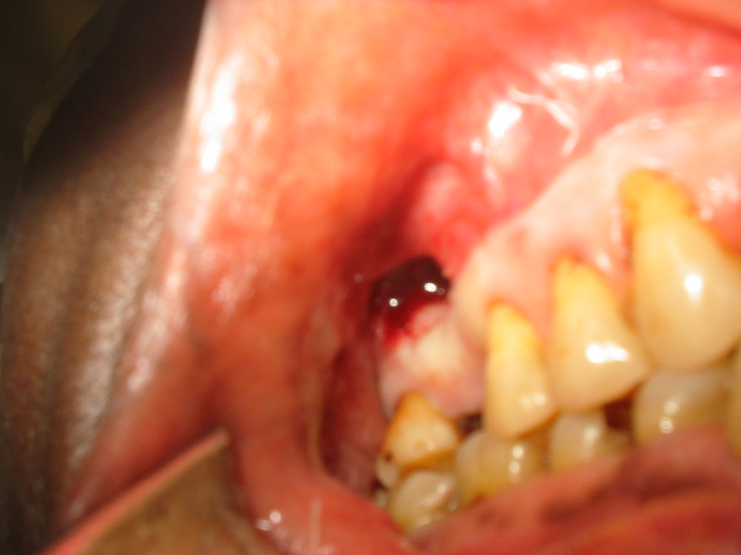

Figure 2. Pedicled buccal fat pad (BFP) being advanced to the site after adequate mobilization.

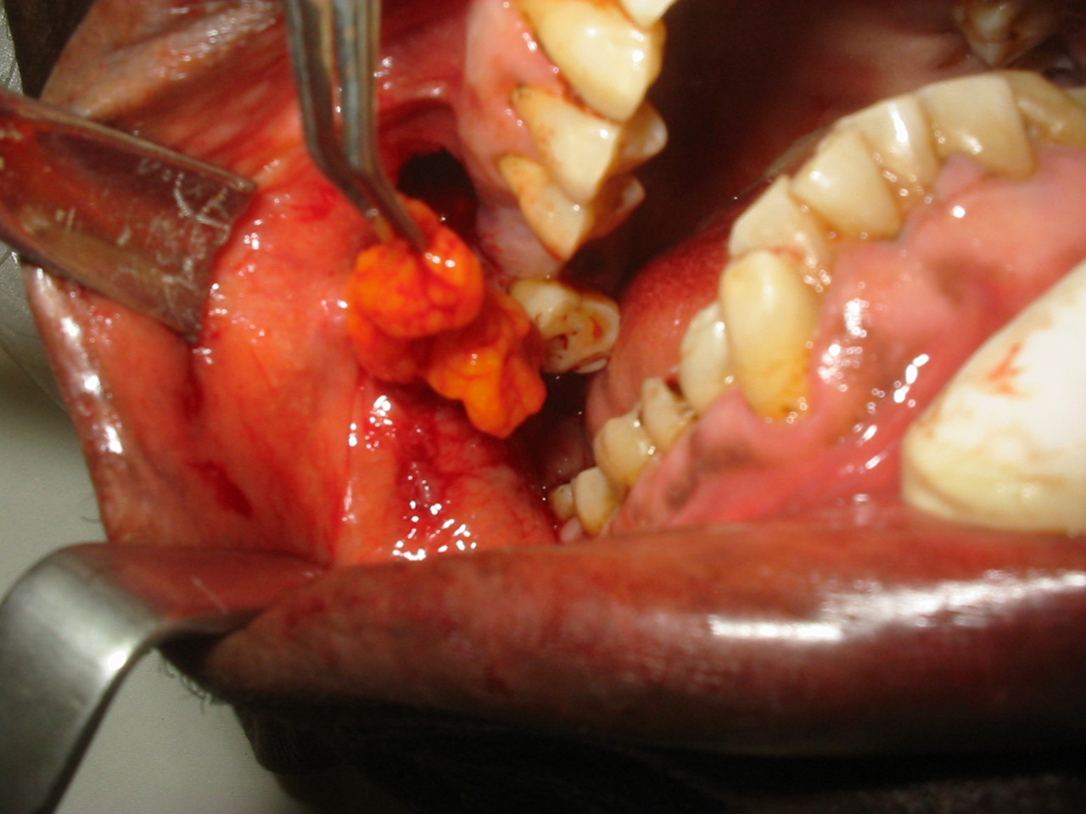
A right upper vestibular horizontal incision, posterior to the second molar was made and this was extended the posterior margin of the fistula to expose the BFP. Careful manipulation and blunt dissection was done to fully mobilize and advance the flap to the recipient site (Figure 2).

The flap was sutured in place with simple interrupted 3/0 black silk sutures (Figure 3).

Figure 3. Buccal fat pad (BFP) sutured in place
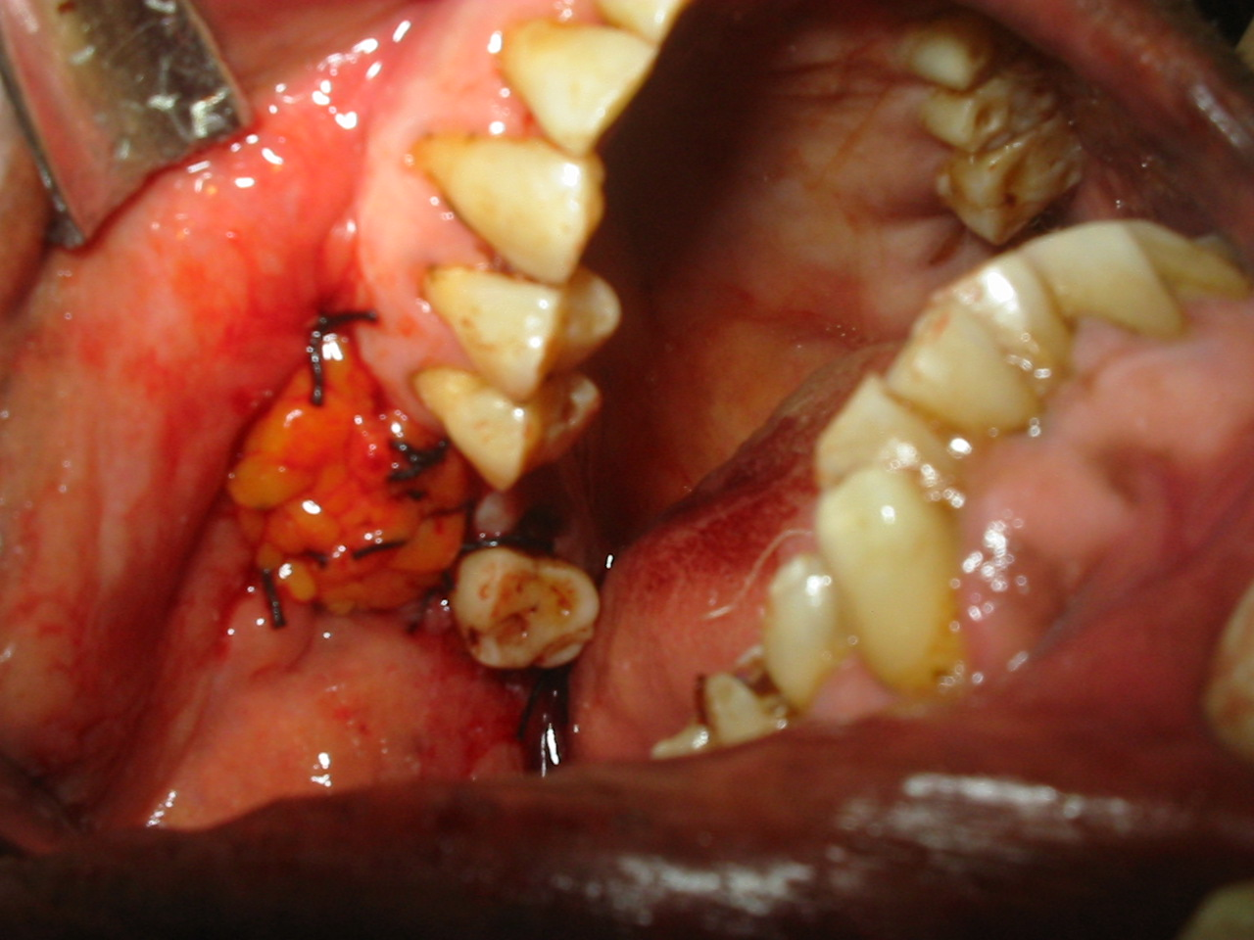
The incision was also closed over the bridge segment of the flap with 3/0 black silk sutures.

Figure 4. Complete epithelization of the BFP after 4 weeks.

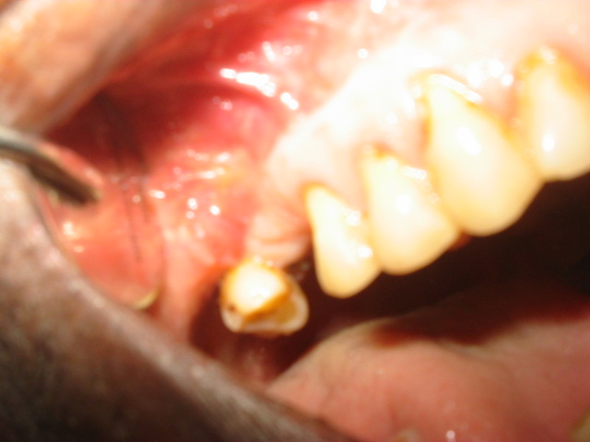
Patient was warned against blowing the nose for 2 weeks. Pre-operative antibiotic was continued for the next 7 days. Patient was reviewed at regular one week intervals and sutures were removed 2 weeks after the procedure. At the end of the 4th week, full epithelization of the flap had taken place (Figure 4). No postoperative complication was observed.

DISCUSSION
The buccal fat pad is an encapsulated, rounded, biconvex specialized fatty tissue which is distinct from subcutaneous fat. It is located between the buccinator muscle medially, the anterior margin of the masseter muscle and the mandibular ramus and zygomatic arch laterally^{4,6}. Buccal fat pad (BFP) was considered a surgical nuisance for many years because of its accidental encounter during various operations in the pterygomandibular area such as tumor, orthognathic, or trauma surgeries^{4,5}. Egyedi ¹¹ in 1977 first reported the use of pedicled BFP for closure of post-surgical maxillary defects. Since then, BFP has become a popular option among surgeons worldwide for the reconstruction of small to medium acquired or congenital soft tissue and bone defects in the oral cavity ⁴⁻⁸. However, the procedure is not commonly practiced in Sub-Saharan Africa as revealed by our literature search. This may be due to lack of awareness of the usefulness of BFP for oral reconstruction among surgeons in this part of the world.

Successful closure of OAF with buccal fat pad is widely reported in the literature^{2,7,10,12}. Stajcic¹² reported the use of pedicled BFP in the closure of oro-nasal and oro-antral communications following extractions in 56 patients with excellent results. Despite postoperative infection in 1 patient and partial necrosis in 2 patients, all his flaps were reported to be successful. In another report by el-Hakim and el-Fakharany¹⁰ the use of pedicled BFP was compared with palatal rotation flap in closure of antral communication and palatal defects resulting from tumor resection. They found BFP to be consistently successful, preserving the normal anatomical architecture of the oral mucosa. No denuded area requiring secondary granulation was required as in the case of palatal flaps. Pedicled BFP is also considered as a reliable back-up procedure in the event of failure of other techniques^{7,10}. This was also confirmed by our case. Yilmaz et al², Pandolfi et al¹³ and Dolanmaz et al¹⁴ also reported good results with the use of BFP in the closure of oro-antral/ oro-nasal communications.

Pedicled buccal fat pad has also been employed in the closure of surgical defects following tumor excision⁷, excision of leukoplakia and submucous fibrosis^{15,16}, as well as closure of primary and secondary palatal clefts^{9,17}, and coverage of maxillary and mandibular bone grafts^{6,18}. Although, no complication was observed in our case, complications in large series range between 3.1- 6.9%^{4,7,8,19}. These included partial necrosis, infection, excessive scarring, excessive granulation and sulcus obliteration. The size of the defect in this report was 1.8cm x 1.3 cm, pedicled BFP had been successfully employed in the coverage of 7cm x 4cm x 3cm defects⁵. However, over-enthusiastic usage of BFP in covering very large defects should be avoided^{4,5}.

Complete epithelization of the BFP was observed after 4 weeks of inset in our patient. This is in agreement with the established facts in the literature^{4,5,7}. Egyedi¹¹ recommended coverage of the exposed BFP with a skin graft, however our case confirmed other previous reports that epithelization of the flap does take place without split skin graft cover ^{2, 4, 5, 13} after 3-4 weeks of inset^{4,5,7}. Histology of the healed tissue at the sites of graft have confirmed that epithelization does indeed take place, although the origin of this epithelium is not clear^{4,7,20}. The advantages of BFP include ease of harvesting, simplicity, versatility, low rate of complications as well as quick surgical technique^{4,5,7,12}. The operation as demonstrated in this report can also be performed with one incision, affecting neither the appearance nor function of the area. The fact that BFP is located in the same surgical field as the defects to be covered and the possibility of harvesting under local anaesthesia are added advantages.

In conclusion, pedicled buccal fat pad is a reliable flap for the repair of oro-antral fistula. The easy mobilization of the BFP and its excellent blood supply and minimal donor site morbidity makes it an ideal flap. It should also be considered as a reliable back-up procedure in the event of failure of other techniques as demonstrated by this report.

REFERENCES
- Seward GR, Harris M, McGowan DA. Killey and Kay’s Outline of oral surgery Part 1. 2nd ed pp 241- 247. Bristol: IOP Publishing Ltd, 1987.
- Yilmaz T, Suslu AE, Gursel B. Treatment of oroantral fistula: experience with 27 cases. Am J Otolaryngol 2003; 24 (4): 221-223.
- Archer WH. Oral and maxillofacial Surgery. 5th ed pp 1607-1618. Philadelphia: W.B. Saunders Company, 1975.
- Samman N, Cheung LK, Tideman H. The buccal fat pad in oral reconstruction. Int J. Oral Maxillofac Surg 1993; 22: 2-6.
- Rapidis AD, Alexandridis CA, Eleftheriadis E, Angelopoulos AP. The use of the buccal fat pad for reconstruction of oral defects: Review of the literature and report of 15 cases. J Oral Maxillofac Surg 2000; 58: 158-163.
- Liversedge RL, Wong K. Use of the buccal fat pad in maxillary and sinus grafting of the severely atrophic maxilla preparatory to implant reconstruction of the partially or completely edentulous patients: Technical note. Int J Oral Maxillofac Implants 2002; 17: 424-428
- Baumann A, Ewers R. Application of the buccal fat pad in oral reconstruction. J Oral Maxillofac Surg 2000; 58: 389-392.
- Martin-Granizo R, Naval L, Costas A, Goizueta C, Rodriguez F et al. Use of buccal fat pad to repair intra-oral defects: A review of 30 cases. Br J Oral Maxillofac Surg 1997; 35 (2): 81-84.
- Kim YK. The use of a pedicled buccal fat pad graft for bone coverage in primary palatorrhapy: a case report. J Oral Maxillofac Surg 2001; 59 (12): 1499-1501.
- el-Hakim IE, el-Fakharany AM. The use of the pedicled buccal fat pad (BFP) and palatal rotating flaps in closure of oroantral communication and palatal defects. J Laryngol Otol 1999; 113 (9): 834-838.
- Egyedi P. Utilization of the buccal fat pad for closure of oro-antral and/or oro-nasal communications. J Maxillofac Surg 1977; 5: 241-244.
- Stajcic Z. The buccal fat in the closure of oro-nasal communications: A study of 56 cases. J Craniomaxillofac Surg 1992; 20: 193-197.
- Pandolfi PJ, Yavuzer R, Jackson IT. Three layer closure of an oroantral-cutaneous defect. Int J Oral Maxillofac Surg 2000; 29 (1): 24-26.
- Dolanmaz D, Tuz H, Bayraktar S, Metin M, Erdem M, Baykul T. Use of pedicled buccal fat pad in the closure of oroantral communication: analysis of 75 cases. Quintessence Int 2004; 35 (3): 241-246.
- Ho KH. Excision of cheek leukoplakia and lining the defect with pedicled fat pad graft. Br Dent J 1989; 166 (12): 455 - 456.
- Yeh CJ. Application of the buccal fat pad to the surgical treatment of oral submucous fibrosis. Int J Oral Maxillofac Surg 1996; 25(2): 130-133.
- Hudson JW, Anderson JG, Russell RM Jr, Anderson N, Chambers K. Use of pedicled fat pad graft as an adjunct in the reconstruction of palatal cleft defects. Oral Surg 1995; 80: 24-27.
- Vuillemin T, Raveh J, Ramon Y. Reconstruction of the maxilla with bone grafts supported by the buccal fat pad. J Oral Maxillofac Surg 1988; 46:100-105.
- Dean A, Alamillos F, Garcia-Lopez A, Sanchez J, Penalba M. The buccal fat pad in oral reconstruction. Head Neck 2001; 23 (5): 383-388.
- Chao CK, Chang LC, Liu SY, Wang JJ. Histologic examination of pedicled buccal fat pad in oral submucous fibrosis. J Oral Maxillofac Surg 2002; 60 (10): 1131-4.

